Real Time Searches on a Local Social Network
Alexander Faaborg, Judith Donath, Henry Lieberman
MIT Media Lab
20 Ames Street, Building E15
Cambridge, MA 02139
faaborg@media.mit.edu, donath@media.mit.edu, lieber@media.mit.edu

ABSTRACT

Due to the recent popularity of peer-to-peer networks, even many novice computer users are familiar with the idea of broadcasting searches across a network. Cell phone contact lists represent a very large peer-to-peer network, in a very literal sense. In this paper we describe a cell phone based application that allows users to perform real time searches on their local social network, against pieces of information that their contacts have provided about themselves. We discuss several design decisions and privacy mechanisms implemented in the hope of improving user’s socialization.

Author Keywords
Social Networks, Computer Mediated Communication, Matchmaking, Agents, Common Sense Reasoning.

ACM Classification Keywords
H.5.2. User Interfaces: Interaction Styles
H.3.3. Information Search and Retrieval

Introduction
Despite their inherently social purpose, the increased processing power and network connectivity in modern cell phones is rarely utilized for social applications. Modern processors, higher resolution screens and increased memory have been mainly utilized by games. And aside from text messaging, the network bandwidth available to phones is mainly used for solitary tasks like reading horoscopes and news stories. We have developed a cell phone based application that uses the devices processing power and network connectivity for a social purpose: to allow users to perform real time searches on their local social network, against pieces of information that their contacts have provided about themselves. The system we have designed is similar to Expert Finder [1], a software agent to help novices find experts in a particular domain, and Friendster [2] a Web site that uses social networks for the purposes of dating and meeting new people. However, unlike Friendster, profiles in our system are not publicly viewable in their entirety, and we have implemented several other privacy mechanisms that are discussed in detail in later sections.
To manage their personal information and privacy settings, users log on to a web site, shown in Figure 1.
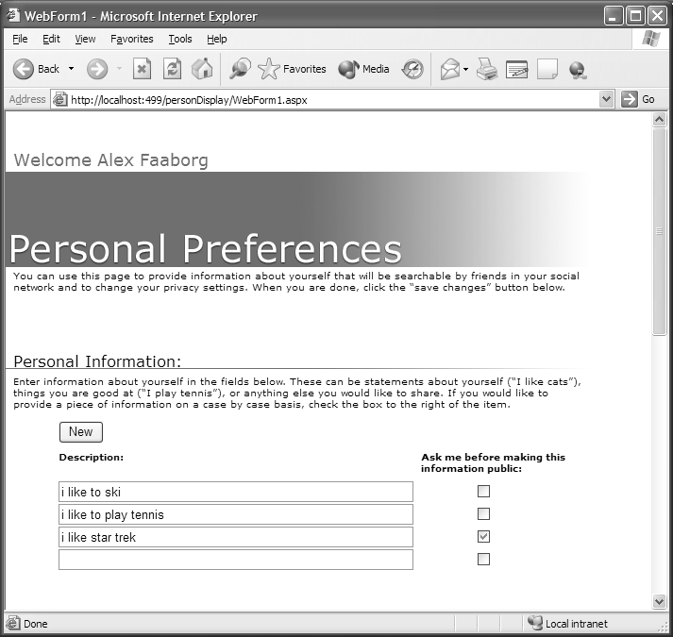
Figure 1. Users enter personal information about themselves.
Here user’s can enter statements about their interests and activities. Because these profiles are not publicly viewable, and by providing additional privacy mechanisms, it is our hope that people will provide more interesting, useful, and reveling information then the stereotypical statements usually found in online profiles. Users can then search against their contacts information and one level beyond in their social network using a cell phone based application, which is shown in Figure 2.
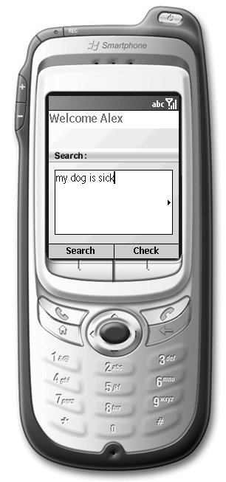
Figure 2. A user performs a goal based search on their local social network
The system uses common sense reasoning algorithms when processing searches to (1) expand upon the user’s query to contextually similar topics, and (2) allow the user to entered goal-based searches, like the one displayed in Figure 2.
A problem facing text searches over a limited number of profiles is that the probability of direct matches is low. To deal with this problem our application uses common sense reasoning to intelligently expand on the user’s query. For instance, if a user entered the search “I want to play tennis” the system might return the result “Contact Ben, Ben said ‘I like to play basketball’”. While this is not a direct match, the two phrases are contextually similar.
A second problem facing text searches is that novice users will often enter goal-based statements that can not be resolved with simple keyword matching. For instance a user might type “my dog is sick” rather then “I need to find a good veterinarian.” Our system employs a technique used to process goal-based web searches in a project called GOOSE [3].
Both of the above problems are solved using Open Mind, a knowledge base of 600,000 common sense facts [4,5], and OMCSNet [6], a semantic network of 280,000 concepts and relationships.

GIVING SOFTWARE COMMON SENSE KNOWLEDGE
The Open Mind common sense knowledge base consists of natural language statements entered over the last three years by volunteers on the Web. While it does not contain a complete set of all the common sense knowledge found in the world, its knowledge base is sufficiently large enough to be useful in real world applications. OMCSNet is a semantic network of concepts built using the statements in Open Mind. OMCSNet is similar to WordNet [7] in that it is a large semantic network of concepts, however OMCSNet contains everyday knowledge about the world, while WordNet follows a more formal and taxonomic structure. For instance, WordNet would identify a dog as a type of canine, which is a type of carnivore, which is a kind of placental mammal. OMCSNet identifies a dog as a type of pet [6].

Enhancing Socialization THROUGH mechanisms for PriVacy
Because users access our system through cell phones, a device people often keep with them at all times, we have given users the ability to make statements in their profile public in real time, on a case by case basis.
To give an example, consider Alex, a college student who enjoys watching the television show Star Trek. Knowing that this information could be considered embarrassing in some social situations, the student decides to check “ask me before making this information public” after entering the statement into his profile.

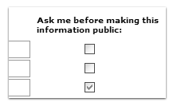
Figure 3. User’s can decide to release information about themselves on a case by case basis.

After checking this box, the system prompts Alex on his phone to decide if he would like to release the information every time it could successfully complete another users’ search. For instance, Alex might receive a message on his phone saying “Anna searched for ‘anyone out there want to watch the Star Trek marathon this weekend?’ Would you like to make the statement ‘I like to watch Star Trek’ public to Anna?” Alex could then click Yes on his phone, and Anna would receive his statement as a result to her search. However, when Alex receives a message from Tom (who is clearly looking for geeky Star Trek fans to beat up) saying “who likes Star Trek…” he can choose to keep his personal information private, assuming that the search is being used as bait.
This same real time privacy system is also useful for dating. For instance, Tom enters the statement “I want to go to the dance on Friday,” and then decides he wants to be prompted before the system makes this information public. By deciding to release this information in real time, he can intentionally hide himself from Susy’s search, but makes his statement public for Jane’s search.

Beyond protecting their personal information, users can also manage which of their contacts are searchable by others, and which are not. This control is achieved through radio button options on the user’s preferences page.

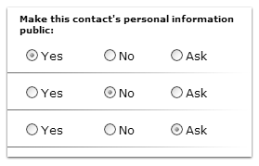
Figure 4. User’s can prevent searches from their friends from reaching certain contacts, or decide on a case by case basis.

In the case of siblings, brothers often do not want their male friends socializing with their sisters, and sisters do not want their female friends socializing with their brothers. Similarly, when a person has a contact list with a mixture of personal and professional contacts, they need the functionality to prevent the groups from inappropriately contacting each other. For instance, a person would likely select the No radio button for their boss if they didn’t want their other friends to contact this person.

The Ask option allows the user to decide how to proceed on a case by case basis. For instance, Jose knows Alex, who knows Ben, and Jose enters a search that is matched by one of Ben’s statements. If Alex has marked Ben with the Ask option, Jose will receive a message saying “Contact Alex, he may know someone who matches your request,” and Alex will receive a message containing Jose’s search and Ben’s matching statement. The Ask option is useful for people who want to monitor and control searches being matched with one of their contacts, however it is also useful for people who enjoy personally makeing matches between their friends, even if the system automatically identified the solution for them. A very social person might mark all of their contacts as Ask, so that they could personally play the role of intermediary.

Evaluation
[The evaluation of our system is still pending, please check back for more information.]

Implementation
The central server to store user’s information and process search requests was implemented in C# using the Microsoft .Net Framework. The Web site for users to set their personal information and privacy setting was implemented in C# using ASP.NET, and connected to the central server using SOAP based XML Web Services. The cell phone application for users to send searches and receive results was also implemented in C#, using the .NET Compact Framework. This application was tested using a Microsoft Smartphone emulator, and also communicated with the central server using SOAP based XML Web Services. In the near future we plan to test the cell phone application on Motorola MPx200 phones. The common sense knowledge from OMCSNet [6] used for query expansion and processing goal-based searches was stored in a large hash table in the central server’s memory.

COnclusion
Throughout our design we have attempted to give users an increased level of control over their personal information compared to the public, static, and generic online profiles often found on dating and matchmaking sites on the Web. We believe that by allowing people to closely protect the information they provide about themselves, they will be increasingly likely to release information that is more valuable, revealing, and relevant. This in turn will result in a system that acts as a catalyst for rich and meaningful socialization in the real world.

ACKNOWLEDGMENTS
Great thanks go to Hugo Liu and Push Singh for their work on OMCSNet and OpenMind. We would also like to the thanks the students in Designing Sociable Media for their insightful feedback on our design decisions.

REFERENCES
- Vivacqua, A., Lieberman, H. Agents to Assist in Finding Help. ACM Conference on Computers and Human Interface. CHI-2000.
- Friendster. http://www.friendster.com
- Liu, H., Lieberman, H., Selker, T. GOOSE: A Goal-Oriented Search Engine With Commonsense. In De Bra, Brusilovsky, Conejo (Eds.): Adaptive Hypermedia and Adaptive Web-Based Systems, Second International Conference, AH 2002.
- Mihalcea, R. and Chklovski, T. Open Mind Word Expert: Creating Large Annotated Data Collections with Web Users' Help. Proc. EACL 2003 Workshop.
- Singh, P., Lin, T., Mueller, E., Lim, G. Perkins, T. and Li Zhu, Wan. Open Mind Common Sense: Knowledge acquisition from the general public. Proc. Ontologies, Databases, and Applications of Semantics for Large Scale Information Systems 2002
- Liu, H., Singh, P. OMCSNet: A Commonsense Inference Toolkit. MIT Media Lab Society Of Mind Group Technical Report SOM02-01. Retrieved from: http://web.media.mit.edu/~push/OMCSNet.pdf
- Fellbaum, Christiane. WordNet: An electronic lexical database. MIT Press, Cambridge, MA, USA, 1998.

